**7D6N -Beijing-Shanghai Tour**

**Period : May, 2020**

**Pax : 10+1Foc;15+1Foc;20+1Foc**

**Hotel : Local 4 star or similar**

**Meal : Nomal meal**

**D1: Beijing (--/L/D)**

After Breakfast in the hotel, visit **Tian An Men Square, Forbidden City,Arcobatic Show,Wangfujing Walking street.** After dinner go to hotel.

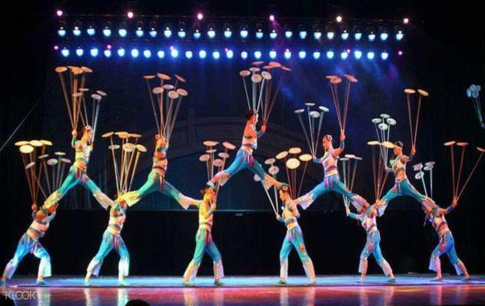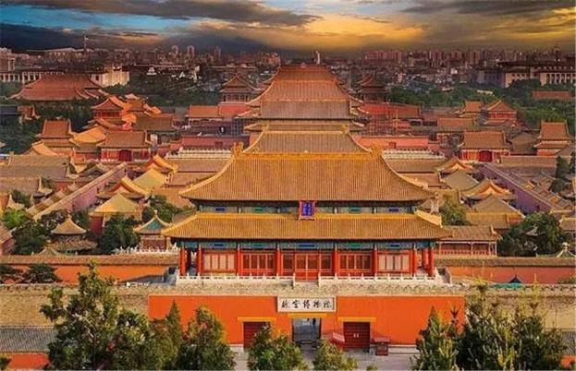**D2: Beijing (B/L/D)**

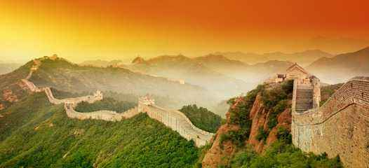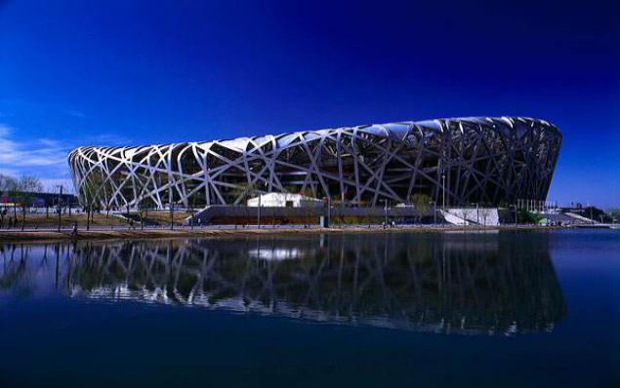After Breakfast in the hotel,visit **Great Wall,outside Beijing 2008 Olympic National Stadium (Bird Nest& Water Cube),Dinner with Peking Roast Duck .** After dinner go to hotel.

**D3: Beijing (B/L/D)**

After Breakfast in the hotel,visit **Summer Palace,Heaven Temple.** After dinner go to hotel.

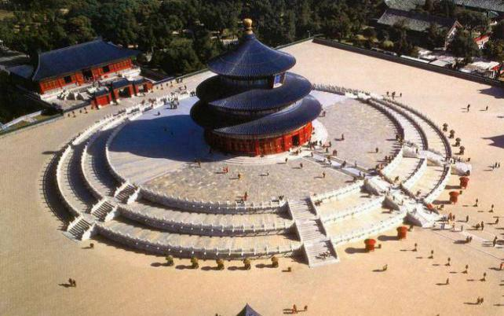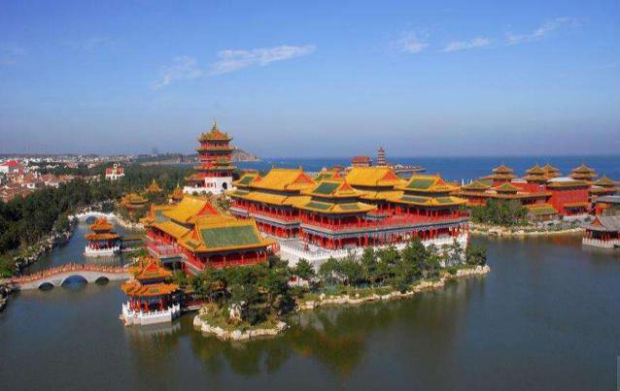**D4: Beijing-Shanghai (B/--/D) by bullet train 6.5H**

After Breakfast in the hotel,then transfer to **Shanghai** **by bullet train(second** **class),**visit **The Bund, Appearance Oriental Pearl, Nanjing Road Pedestrian Street**and thenback hotel for rest.

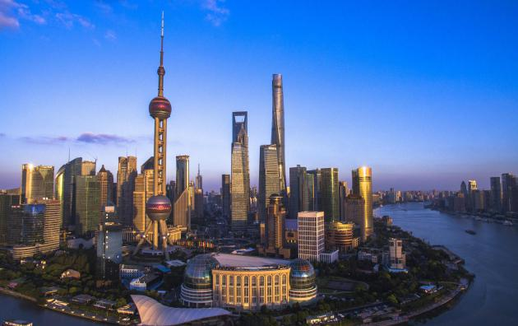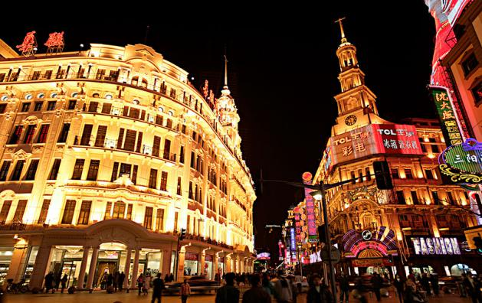

**D5: Shanghai(B/L/D)**

After Breakfast in the hotel, visit **Starbucks baking workshop, Yu Garden, Town God's Temple,**and thenback hotel for rest.

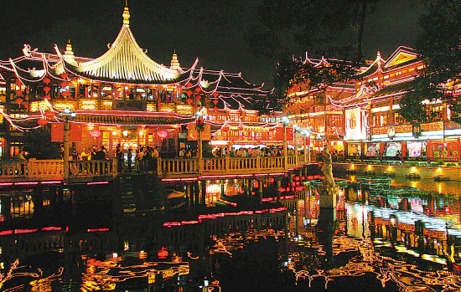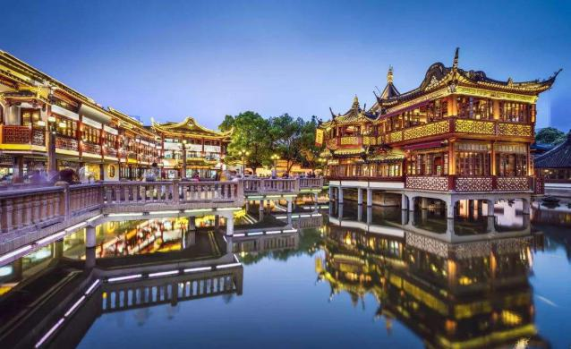**D6:Shanghai(B/L/D)**

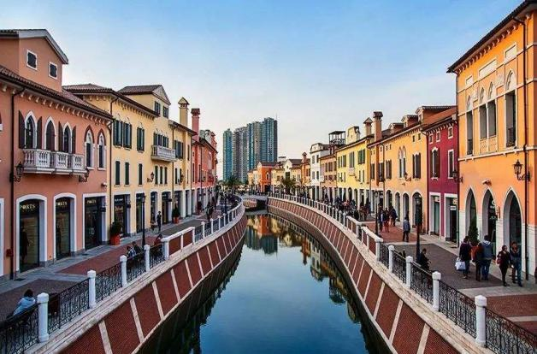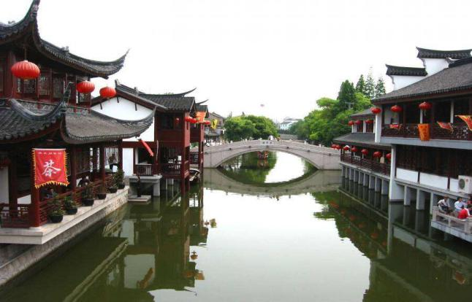After Breakfast in the hotel, visit **Florence Town, Qibao ancient town**and thenback hotel for rest.

**D7:Shanghai - Departure (B/--/--)**

After Breakfast in the hotel, **then transfer to airport,this is the end of tour.**

**Shopping stop:**

**Beijing:Chinese Medicine Center (Foot Bath), baoshutang, Latex;Jade**

**Shanghai:Jewelryl;Tea;Silk**

**Hotel 4****Local or similar**

**Beijing: Apple Hotel Beijing or similar**

[**http://www.sijiapplehotel.com/**](http://www.sijiapplehotel.com/)

## Shanghai:Holiday Inn Express Shanghai New Hongqiao or similar

[**https://hotels.ctrip.com/hotel/532946.html?isFull=F&masterhotelid=532946&hcityid=2#ctm_ref=hod_sr_lst_dl_i_1_21**](https://hotels.ctrip.com/hotel/532946.html?isFull=F&masterhotelid=532946&hcityid=2#ctm_ref=hod_sr_lst_dl_i_1_21)

|  |  |  |  |  |
| --- | --- | --- | --- | --- |
| **PAX** | **Local 4 STAR (per pax)** | | | |
| **TWN（USD）** | **SGL SUPL（USD）** | **CWB(USD)** | **CNB(USD)** |
| **10+1Foc** | **255** | **130** | **255** | **205** |
| **15+1Foc** | **215** | **130** | **215** | **180** |
| **20+1Foc** | **205** | **130** | **205** | **165** |

**The above quotation included:**

1. Transfer in/out

2. Meals

3. Indonesian speaking guide and entrance fee

4. Accommodate in local 4 star hotel

5. Free 1 Bottle of water /Pax/day

6. Accident Insurance

**7. Peking Roast Duck**

**The above quotation excluded:**

1. International flight ticket and airport tax

2. Tips for the guide and driver 4USD/Day/Pax. (Above 10 pax)

3. Tips for potter, waitress & Luggage’s fee

4. Personal consumptions & expenses (laundry, phone, mini bar, etc)

**5.2nd Bullet ticket Beijing-Shanghai:85USD/pax no foc.(Second class)**